MTRN3060 – Minor Project Report

This document provides an overview of the MTRN3060 Minor Project, and the challenges faced in its completion. This document will outline project objectives, milestones, potential applications and learned outcomes.

# Task:

Our task is to write our name on a piece of A4 paper using the IRB120 Robotic Arm. The task requires that we write a minimum of 15 characters on the page, and the edge of what is being written should be within 15mm of the edge of the page. Given my name (Tyler Johnson) is less than 15 characters I have opted to write “Tyler Johnson Stinks” for no reason other than my own amusement. We are tasked with calibrating the pen holder tool in software to match the real world.

# Milestones and Project Components:

In order to more easily complete the project, the task can be broken down into a number of components. Each of the major components are described below:

### Pen Holder and Tool Rigging

The project requires that we are able to adjust our pen position to match its mointing position in the real world. Since we are unable to adjust the pen’s real position, we can rig the pen as a custom mechanism with jogabble joints. Our first joint moves the pen gripper along the first shaft, and our second moves the pen back and forth in the grip.

The end effector coordinate is set to the tip of the pen, so all that is required to calibrate is to measure the distance between the robot arm and the pen grip, and the length of the pen, and adjust in software. This was achieved following the instructions in Practical 4 and my own research.

### Robot Configuration

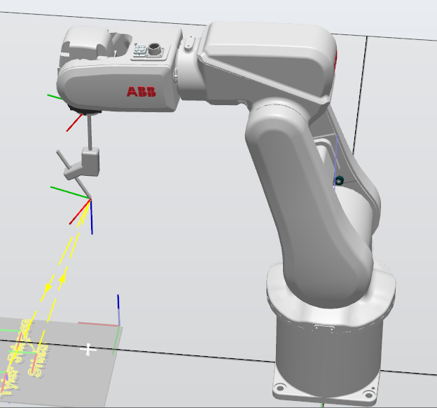The robot being used is the IRB120, a 6 axis robot designed by the ABB Group. After creating a custom mechanism for the pen, I mounted the end effector onto joint 6 of the robot and set a home point as shown. From here we can define our workobject and paths.

### Paths and Move Instructions

To generate paths, I chose to model a to-scale piece of A4 paper with my chosen text size and orientation in Fusion360. From here I could import it as geometry into the workstation and use the Autopath Feature to quickly generate accurate paths. For each word there is a point above it which the robot lifts to, in order to prevent smudging or unwanted lines being drawn.

There are also wait time commands that stop the robot for 0.5 seconds when it reaches the first and last point, this helps the robot stabilize between detailed movements and prevents the robot from cutting corners.

All non-drawing operations at speed v50 to reduce time taken to complete the program. As the robot draws it reduces speed to v30 and zone to z10, this increases stability and accuracy while drawing. When moving to home or a lift point the Joint move type was also used to reduce errors and increase speed.

The Autoconfig feature was extremely helpful in quickly applying the correct configuration for each point, combined with manual input to fix other issues it made configurations quick and easy.

### Calibration

Since I have already modelled the paper to scale, calibrating the simulation is as simple as repositioning the paper and adjusting the configuration of the pen holder joints. Repositioning the paper can be done so long as it is within the robot’s work envelope.

# Simulation and Real-World Outcomes:

To calibrate our simulation to match the real world during the demonstration, I measured the distance between the base of the robot to the table it’s mounted on.

I decided to place my paper on the black table as opposed to the blue block its mounted on as I had issues with singularities when drawing closer to the robot. I offset the workobject down by this value to account for the difference in height. I measured the offset for the pen and pen holder and adjusted the joints to m

The simulation in the real world had no errors and matched what was expected from the simulation. The only issue that was present was the pen was approximately 1cm too high, which meant the pen was not touching the paper. This would have taken 5 seconds to adjust, but due to poor scheduling, lack of time during the practical and the sheer number of other students that still needed to run their demonstration my time was cut short.

In order to adjust my code to fix this issue, it would be as simple as moving the workobject relative to the paper down 1cm. This would account for the difference in height quickly and easily. The pen joints can also be adjusted to achieve the same result, either by moving the gripper attachment or the pen itself down.

# Applications:

Using a robotic arm like this has some distinct advantages in certain circumstances. Using it as a pen plotter, as we are, the arm is able to move multiple joints at once in 3 Dimensions with 6 Degrees of freedom. Most industry standard pen plotters use only 3 linear degrees of freedom, and are similar to CNC mills in that they can move in X and Y but apply the pen only in the Z axis. Using an articulated robot such as the IRB120 we can control the pen more accurately and apply it to objects in 3 dimensions from theoretically any angle.

Articulated robots such as this have many other applications in both industrial, medical, and logistical applications. Using a gripper attachment it can manipulate many other objects in similar fashion, and using extra sensors such as cameras, proximity sensors and load cells to more carefully, effectively, and consistently pick up both known and unknown objects.

# Learning Outcomes:

Overall, this project taught me a great deal about programming and controlling articulated robots. Below are a several highlights and lessons learned from completing this project.

* Singularity errors are common when moving the robot between two points with different orientations, orientations can be copied and pasted from one point to another to easily line them up.
* The robot controller will attempt to line up the end effector coordinate system with the coordinate system of the point being moved to, its is critical to consider this.
* I learned the process for creating custom mechanisms and mounting them as the end effector.
* I developed a process for creating complex paths in 3-dimensional space and linking those paths together with appropriate move instructions.
* I learned how to properly calibrate my simulation to reflect real world scenarios and applications, including positioning relative to the robot and other objects.
* I developed my ability to devise simple and effective solutions to complex problems using a number of new and familiar technologies and techniques.

**A video of the simulation running will be included in the submission**